Database design of E - COMMERCE

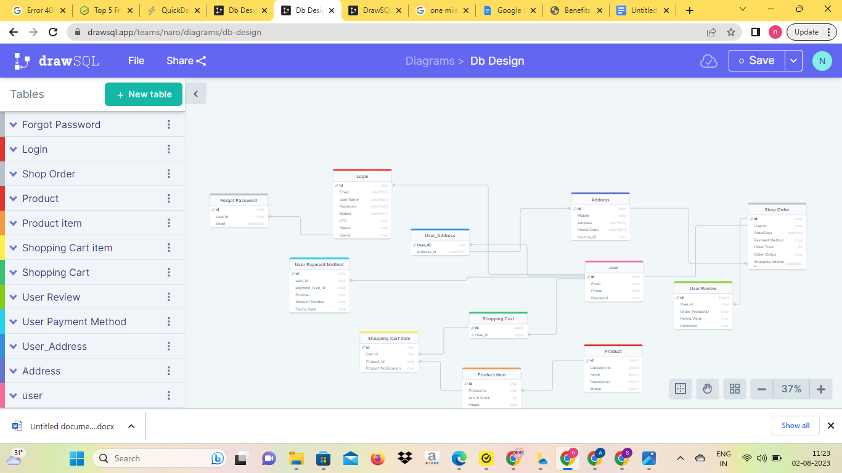

Login table –

With data **Emai**l - **User Nam**e with two fields

Mobile No , with OTP for 2ND level verification ,

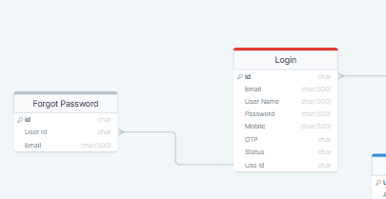

Id - Primary Key ,

User Id is **Foreign key**

**If Status is Failed - Forgot password send the link at given Email for updating Password**

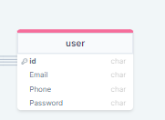

User Field with id - primary Key

And Email,phone , password are there data

Address field with ID - Primary key

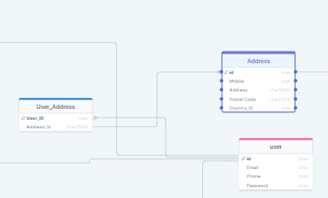

Other fields are user Address Data

User-Address field is Address_id as **Foreign key** connected with id field with Address

User Id is Foreign key connected with Table User field with many to one relation

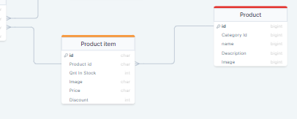

Product with **id as PRIMARY KEY** and other fields for product descriptions

Product Table connect with Product Item Table with Product Id as **Foreign key** with details about that Product like image ,quantity ,price ,discount

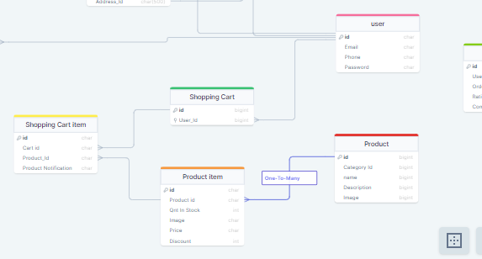

Shopping cart with Id as primary key and user id as Foreign key connected with user Table

Shopping Cart Item Table with Product id and cart id as **Foreign key** connected with shopping cart and Product item respectively

The Product will get Notification of Purchase Products

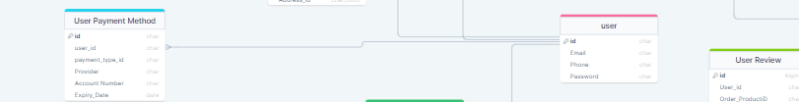

User Payment method Table with Account Number , payment type data

User id is A Foreign Connect with user table with id as primary key many to one relation ship

Shop Order Table with id as Primary key , Order date 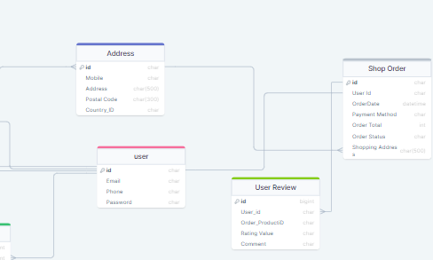

Order Status will give status of Order - like Shipped , In way ,delivered

User id is a foreign key connect with user table

User Review Table for user can give review like Rating and comments with user id as foreign key connected with shop order id field with many to one relationship